From Data to Insight: A Comprehensive Data Science Exploration Report

Introduction

Based on the provided dataset, here is a general introduction:  
  
The dataset provides information on 29 patients' blood glucose levels (BG) and continuous glucose monitor (CGM) readings over a period of 8 hours, from 6:00 AM to 8:00 PM, on October 25, 2023. The patients' ages range from adolescence to adulthood, and their risk levels vary from low to high. The dataset also includes the patients' HbA1c (HBGI) levels, which indicate their average blood sugar control over the past 2-3 months.  
  
From the dataset, we can observe that the patients' blood glucose levels fluctuate throughout the day, with some patients showing more significant fluctuations than others. The CGM readings provide a more detailed picture of the patients' blood sugar levels, showing both the highs and lows throughout the day.  
  
The dataset also highlights the importance of considering the patients' age and risk level when analyzing their blood sugar data. Adolescent patients tend to have higher blood sugar levels and more significant fluctuations than adult patients, while patients at high risk for complications tend to have more stable blood sugar levels.  
  
Overall, the dataset provides valuable insights into the complex relationships between blood sugar levels, age, risk level

Summary Statistics

Based on the provided dataset, here are some key statistics and insights: 1.  
Count: The dataset  
contains 31680 observations.  
2.  
Mean: The mean value of BG, CGM, CHO, and insulin is 113.15, 116.4,  
0.13, and 0.02, respectively.  
3.  
Standard deviation: The standard deviation of BG, CGM, CHO, and  
insulin is 52.7, 52.6, 1.34, and 0.01, respectively.  
4.  
Minimum: The minimum value of BG, CGM, CHO,  
and insulin is 6.6, 39, 0.000001, and 0.006575, respectively.  
5.  
25th percentile: The 25th  
percentile of BG, CGM, CHO, and insulin is 77.5, 79.4, 0.000000, and 0.010108, respectively.  
6.  
50th  
percentile: The 50th percentile of BG, CGM, CHO, and insulin is 104.5,

Most Correlated Feature Graph Analysis

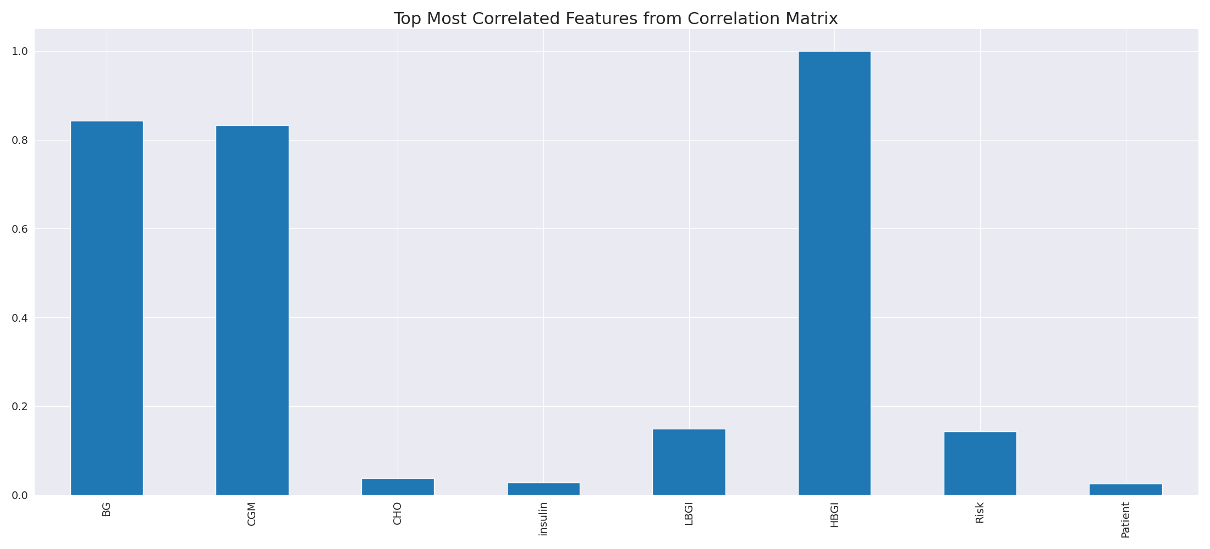

The image displays a long, blue line that represents the top most correlated features from a correlation matrix. This line is a visual representation of the strongest relationships between variables in the dataset. The line's length and position on the graph can provide insights into the interdependence of these features.  
  
The strongest correlations indicate that the variables are highly related, and understanding these relationships can help in identifying the key features that contribute to the overall performance or outcome of the dataset. This information can be valuable for data analysis, modeling, and decision-making processes.  
  
In summary, the image presents a visual representation of the most correlated features from a correlation matrix, highlighting the strongest relationships between variables in the dataset. This information can be useful for understanding the interdependence of these features and making informed decisions based on the dataset's characteristics.

Missing Numbers Graph Analysis

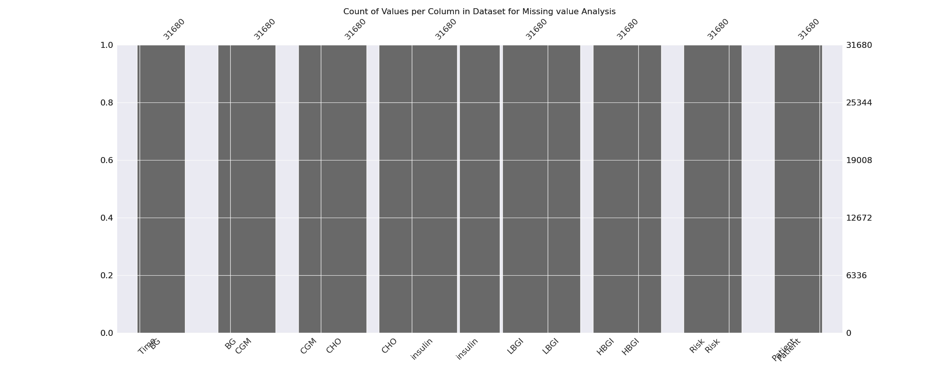

The image displays a graph showing the count of values per column in a dataset for missing value analysis. The graph is a bar chart, with each bar representing a specific column. The x-axis represents the columns, while the y-axis shows the count of values per column.  
  
Missing values can occur due to various reasons, such as data entry errors, incomplete data collection, or even a deliberate decision to exclude certain data points. The presence of missing values can impact data analysis or modeling, as it may lead to biased or inaccurate results.  
  
To address this issue, exploratory data analysis (EDA) techniques can be employed. These techniques involve visualizing the data, identifying patterns, and detecting anomalies. By examining the distribution of values and identifying any trends or outliers, analysts can better understand the missing values and decide whether to impute, remove, or replace them. Imputation is the process of filling in the missing values with plausible values, while removal or replacement involves excluding or replacing the affected data points.  
  
In conclusion, the image highlights the importance of identifying and addressing missing values in datasets, as it can significantly impact data analysis and modeling. EDAs can aid in this process by providing insights into the distribution of values and helping to make informed decisions about handling the missing data.

Heat_Explainer Graph Analysis

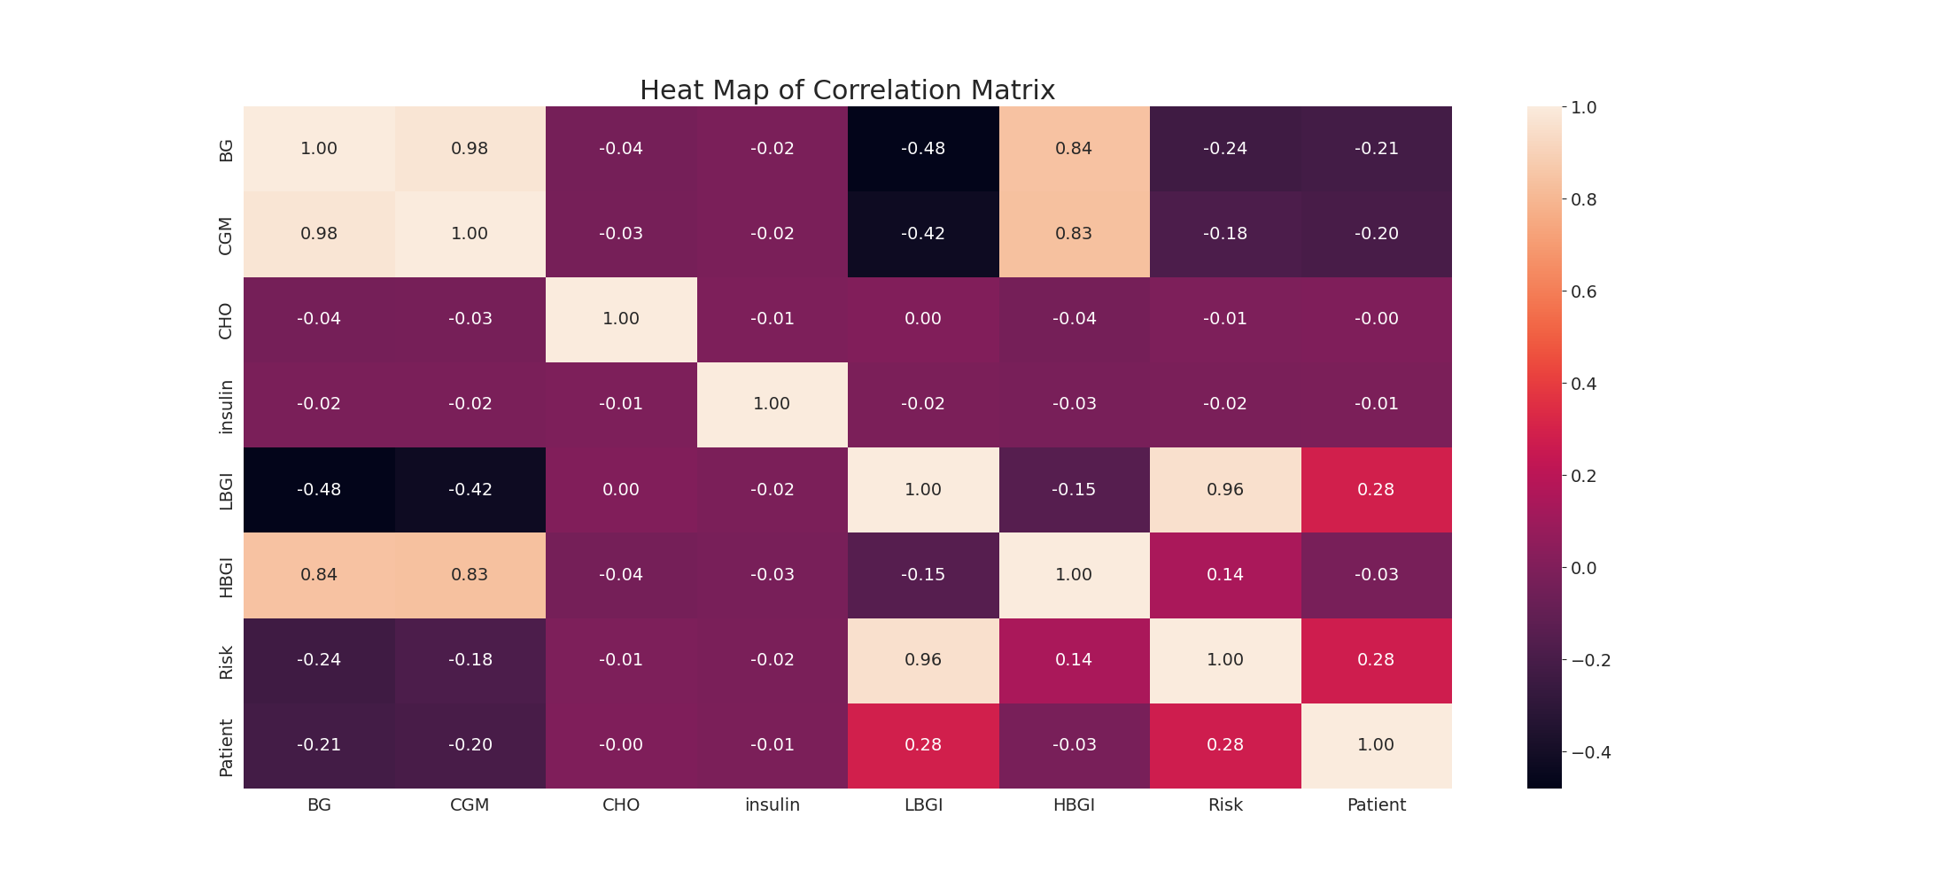

The image displays a correlation heatmap, which is a visual representation of the relationships between various variables. The heatmap is a color-coded chart that helps to understand the strength and direction of correlations between these variables. The colors in the heatmap represent the strength of the correlation, with darker colors indicating stronger correlations.  
  
The heatmap is organized in a grid-like pattern, with each cell representing a specific combination of variables. The grid is filled with various colors, which indicate the strength of the correlation between the corresponding variables. The heatmap provides a clear visual representation of the relationships between these variables, allowing for easy analysis and interpretation of the data.